**PERSONAL BRAND ANALYSIS AND ACTION PLAN**

Student name: Yezehao Huai

PID: 5965823

**VALUES**

1. Unity

2. Honesty

3. Industry

4. Conscientious

5. Respect

**Leadership Philosophy**

From my perspective, the leadership is a person who have non-authority influence, lead people take full advantage of resources and achieve the aim effectively.

PURPOSE: Complete Master’s Degree with good grades

VISION: Become a great computer science engineer

MISSION: Accumulate enough knowledge and experience during school, then find a suitable job

**SWOT ANALYSIS** (focus on your EI profile)

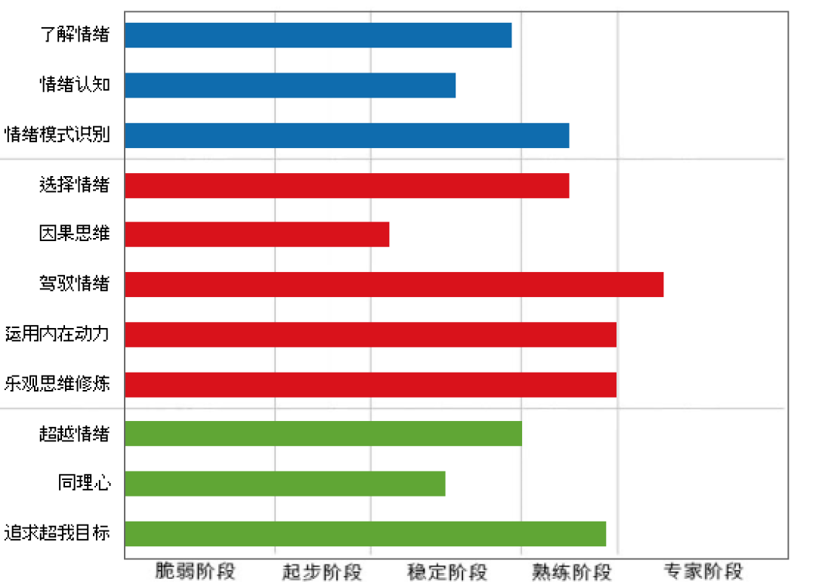

|  |  |
| --- | --- |
| **Strengths:**  Control the mood  Sensible thinking  Use internal forces  Optimistic | **Weaknesses:**  Lack of empathy  Impulsive decision  Emotion understanding |
| **Opportunities:**  Young and full of energy  Solve problem by using Chinese resource | **Threats:**  Don’t have enough work experience  Can’t communicate with American very well as a foreigner. |

**ACTION PLAN**

|  |  |  |  |  |  |  |  |
| --- | --- | --- | --- | --- | --- | --- | --- |
| GOALS/TARGET | TIMEFRAME | STRENGTH(S) | WEAKNESS(S) | STRATEGIES | MEASUREMENT | EXPECTED OUTCOME | ACTUAL OUTCOME |
| Complete Master’s Degree | 04/28/2018 | Math | Language | Practice English everyday | 100% increase | Use English  fluently | TBD |
| Find an internship | 09/30/2018 | Computer Science | Work experience | Work with professor to get experience | 100% increase | Find a good internship | TBD |
| Find a suitable job | 12/30/2019 | Computer Science | Work experience | Accumulate experience during internship | 100% increase | Get a great job in famous computer company | TBD |
| … | … | … | … | … | … | … | … |

**VALUE PROPOSITION**

My value proposition is “Be more productive with less effort”. I believe that draw up a plan and strategy before working is crucial. A good plan and strategy will bring a clear vision. This doesn’t mean don’t work hard. Actually, we have to work in a smart and effective way to achieve “more productive with less effort”. In my opinion, using the least amount of resources to produce the greatest value is the key to success.